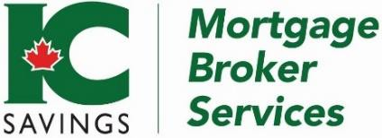

|  |  |
| --- | --- |
| Interest Only Mortgage  Short term payment relief | |
| Loan Purpose | * Purchase or refinance |
| Mortgage type | * First mortgage only |
| LTV | * Up to 65% |
| Qualifying rate | * Contract rate on 30-year amortization |
| Rate Premium | * 25 bps over IC Savings Everyday Preferred Rates |
| Rate calculation | * Interest only |
| Payment Frequency | * Monthly |
| Debt Servicing | * 50/50 verifiable income 45/45 unverifiable income (BFS) |
| Credit bureau | * Must be dated within 30 days of application |
| Beacon Score | * Minimum 580 |
| Term | * 1 – 2 years |
| Amortization | * None |
| Documentation | * All IC Savings broker documentation and conditions must be satisfied before solicitor is instructed |
| Payout privilege | * Closed unless arms-length sale agreement provided. * Early payout: three months interest or IRD, whichever is greater |
| Property type | * Owner occupied. * Residential properties with 1-4 units * In prime urban markets with continuing demand for resale |
| Appraisal | * To be completed by an appraiser on the IC Savings Approved Appraisers List |
| Rate hold | * Purchase: 90 days * Refinance: 60 days |
| Property taxes | * Client is responsible for payment |
| Application Fee | * Standard 1% lender fee split |

[**www.icsmb.ca**](http://www.icsmb.ca)Updated: January 9, 2024